

**LAB 1:**

**Basic Logic Gates, Electronic Circuit Interfacing, Basic ALU, 7 segment display, ICs based interfacing application.**

**MCTA 3202**

GROUP F

GROUP MEMBERS MATRIC NO

1. Muhammad Naufal bin Mohammad Bakri 2110333

2. Muhammad Khairul Aiman bin Mohamad Basari 2113571

3. Muhammad Nabil Ikhmal Bin Khairil Rizal 2114577

4. Muhammad Zakwan Zikri bin Irwan Affandi 2111033

5. Che Muhammad Danial Bin Che Suhaimi 2119075

DATE OF SUBMISSION :

25th October 2023

**Abstract**

The objective of this experiment was to interface a 7-segment display with an Arduino microcontroller, exploring the principles of driving and controlling the display to visualize numeric data. The methodology involved setting up the hardware, including the connection of the 7-segment display to the Arduino, and programming the microcontroller to control the display's segments.

Key findings revealed that the Arduino, when programmed appropriately, can effectively control the 7-segment display, enabling the display of numeric characters. The experiment highlighted the importance of understanding common-cathode or common-anode displays and implementing multiplexing for efficient use of pins.

In conclusion, this experiment provided hands-on experience in working with 7-segment displays and reinforced concepts related to input/output handling, coding, and library utilization in an Arduino project. The knowledge gained here serves as a fundamental building block for students and enthusiasts in the field of electronics and embedded systems, opening doors to more advanced applications and projects.

**Table of Contents:**

•List of sections and subsections with page numbers.

| CONTENT | PAGE | REMARK |
| --- | --- | --- |
| INTRODUCTION | 4 |  |
| MATERIALS AND EQUIPMENT | 5 |  |
| EXPERIMENTAL SETUP | 5 |  |
| METHODOLOGY | 6 |  |
| RESULT (OBSERVATION) | 7 |  |
| DISCUSSION | 8 |  |
| CONCLUSION | 9 |  |
| REFERENCES | 10 |  |
| STUDENT’S DECLARATION | 11 |  |

**1. Introduction:**

The objective of this experiment is mainly to help students understand how to interface a 7-segment display with an Arduino Uno and how to control it manually using buttons.

**• Overview of the experiment's purpose and objectives.**

The objective of this lab experiment is to demonstrate the fundamental principles of interfacing a 7-segment display with an Arduino. We will discuss the hardware setup, including the connection of the 7-segment display to the Arduino, and the software implementation, which involves programming the Arduino to control the display.

Through this project, we aim to provide hands-on experience in understanding the principles of multiplexing and driving common-cathode 7-segment displays.

**• Background information and relevant theory or concepts.**

A 7-segment display is a commonly used electronic component that provides a simple and effective means of visualizing numerical data. It consists of seven individually controllable segments arranged in the shape of the number "8." Each segment can be turned on or off, allowing for the display of digits from 0 to 9, as well as some alphabetic characters. In this lab report, we explore the implementation of a 7-segment display using an Arduino microcontroller.

From the experiment, we are expecting our seven segment display to successfully displays 10 different numbers and functions respectively as we program it in the arduino as well as the display is able to reset to its initial value at any point of the experiment.

**2. Materials and Equipmen**t:

* Arduino Uno Board
* Common Cathode 7-segment display
* 220 ohm resistor ( 7 of them )
* Jumper wires
* Breadboard
* Push button

**3. Experimental Setup**:

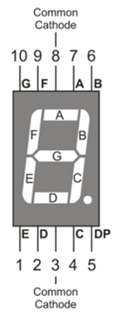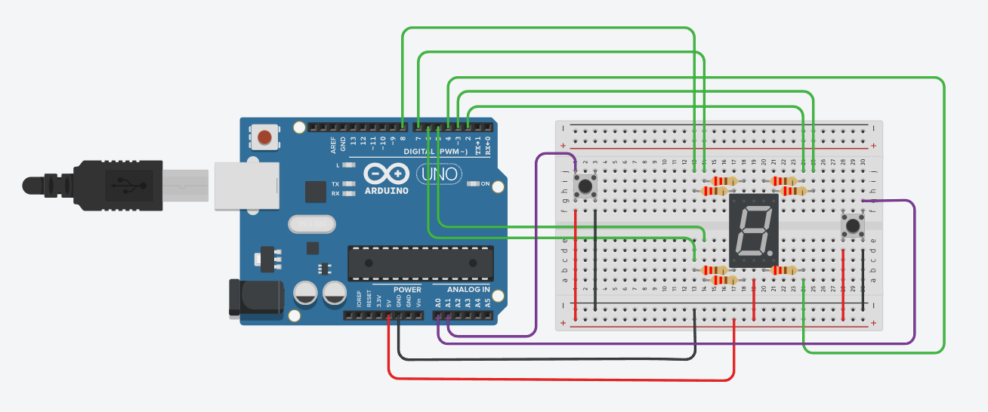

**4. Methodology**:

1. The circuit was built according to the circuit setup instructions.

2.Arduino code was uploaded to the provided Arduino Uno

3.Serial Monitor in Arduino IDE was opened

4.The increment button was pressed to increase the count.The 7-segment display showed the

numbers from 0 to 9 sequentially.

5. The reset button is pressed to reset the count to 0.



**5. Data Collection**:

We used seven segment display to display the respective numbers with every click of the push button starting from 0 counting up until 9 then repeat the cycle endlessly.

The reset button is also used in our experiment to reset the existing number at any moment back to zero.

**6. Data Analysis:**

From the seven segment display, every segment are able to be controlled by supplying voltage through various pins that is connected to the following pin that controls certain segments.

This can easily be done by using the following code.

digitalWrite (**pinnumber, HIGH/LOW**)

However, in our coding, instead of using the traditional digitalWrite for every single segments, we used the aid of array to decide which segments that we are going to turn on/off from every number from 0 to 9. Other than that, we also used loop to help us automatically access the array.

**7. Results:**

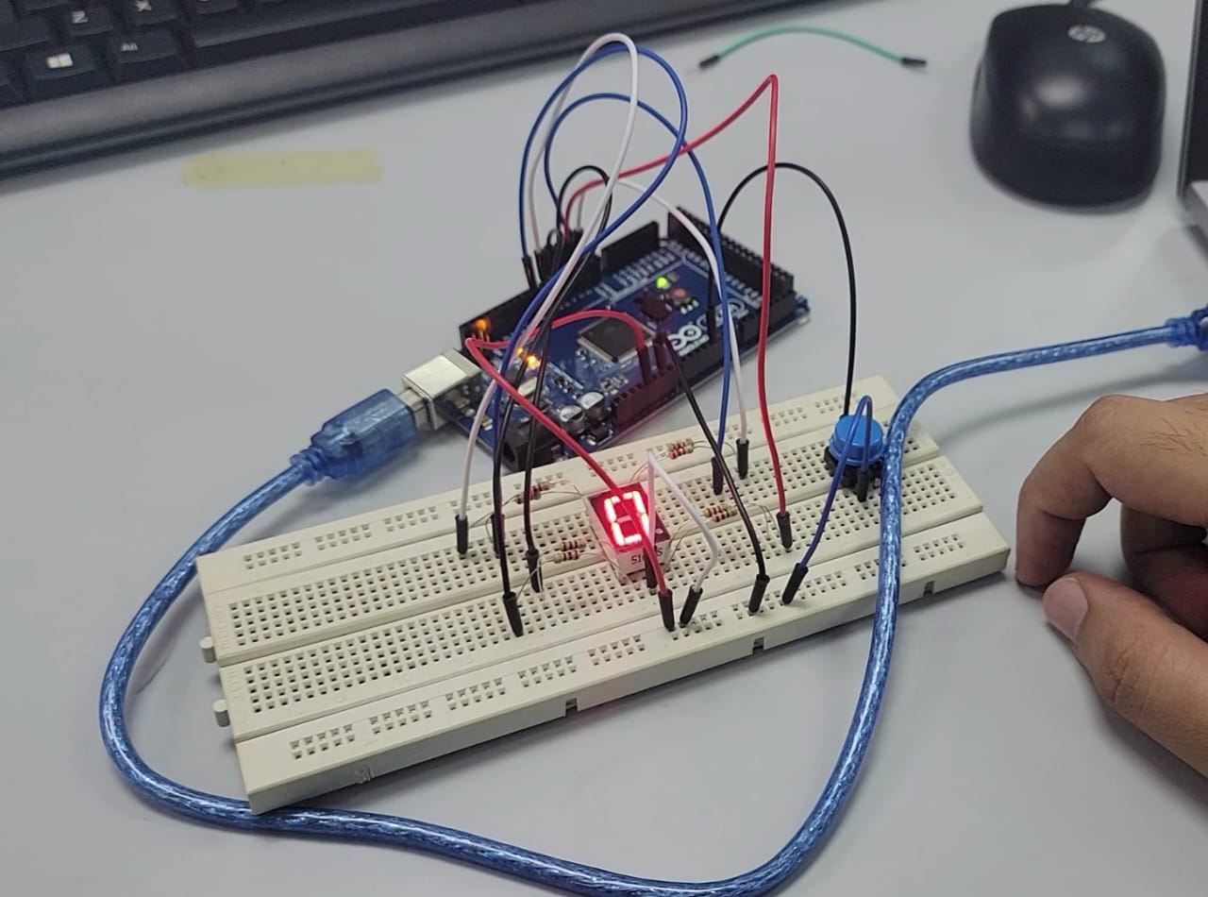

[Video](https://github.com/NotLafuan/GROUP-F-MCTA-3203/blob/main/Week%202/Group%20F%20Week%202.mp4)

Based on our conducted experiment, we are able to increase the number on the 7-segment display with the push of a button. It will start from 0 and then be added by an increment of 1 every time the button has been pushed, until it reaches 9. Even after the button is pushed when it has reach its max, it will reset the number displayed back to 0. This program is able to run as many times as the user desires.

**8. Discussion:**

The source of error that we encounter is that the 7-segment display is easily burned whenever it is not being connected to a 220[Ω](https://www.google.com/search?sca_esv=575988005&rlz=1C1GCEA_enMY1040MY1040&sxsrf=AM9HkKk5Fkw8jXJuHWlPEFYdIPTWlbP3ZQ:1698114358450&q=ohm+1+%CF%89+in&sa=X&ved=2ahUKEwjL-_340I2CAxUi1zgGHZYlCxQQ6BMoAHoECFIQAg) resistor. This is due to human carelessness as they are not alert when they are making the circuit connections.

The limitation for our experiment is that we are only able to code for the increment of a single digit number which is from 0 to 9. Since there is only 7 individual LEDs in the 7-segment display, the highest number that it can represent is 9.

**9. Conclusion:**

In this experiment, our primary objective was to interface a 7-segment display with an Arduino microcontroller to explore the principles of display control and visualization. Our findings have significant educational and practical implications.

Our main findings reveal that, with the proper hardware setup and code implementation, the Arduino can effectively drive a 7-segment display, enabling the display of numerical characters. The experiment validated the hypothesis that Arduino can serve as a versatile tool for controlling electronic components, supporting the integration of 7-segment displays into various projects. The experiment further underscored the importance of understanding display types, pin configurations, and multiplexing to optimize pin usage and display performance.

The broader implications of these findings are twofold. First, it reaffirms the educational value of hands-on experiments in electronics and programming, equipping students with practical skills. Second, the application of 7-segment displays extends to diverse fields, including digital instrumentation, timekeeping devices, and consumer electronics. As an essential building block, our experiment lays the foundation for more complex projects where visualizing numerical data is crucial.

In conclusion, this experiment not only supported our initial hypothesis but also shed light on the broader potential of 7-segment displays in the realm of embedded systems and electronics, offering students and enthusiasts a valuable entry point into this exciting field.

**10. Recommendations:**

Suggestion on increasing the number of 7-segment display being used for the experiment might make it more useful. The more display is available, the more numbers that can be stored. By using 3 of the 7-segments display, user can use it as a counter to keep count of the number of action that they need to keep track of. For example, using it as a tool to keep track of zikir.

**11. References:**

* https://docs.arduino.cc/learn/starting-guide/getting-started-arduino

**Appendices:**



**• Code snippets**

#define NUMBER_AMOUNT 10

#define SEGMENT_AMOUNT 7

int sevenPins[SEGMENT_AMOUNT] = {2, 3, 4, 5, 6, 7, 8};

int sevenSegment[NUMBER_AMOUNT * SEGMENT_AMOUNT] =

{0, 0, 0, 0, 0, 0, 1, // 0

1, 0, 0, 1, 1, 1, 1, // 1

0, 0, 1, 0, 0, 1, 0, // 2

0, 0, 0, 0, 1, 1, 0, // 3

1, 0, 0, 1, 1, 0, 0, // 4

0, 1, 0, 0, 1, 0, 0, // 5

0, 1, 0, 0, 0, 0, 0, // 6

0, 0, 0, 1, 1, 1, 1, // 7

0, 0, 0, 0, 0, 0, 0, // 8

0, 0, 0, 0, 1, 0, 0}; // 9

int currentNumber = 0;

bool clickedAdd = false;

bool clickedReset = false;

const int addButton = A4;

const int resetButton = A5;

void setup()

{

pinMode(addButton, INPUT_PULLUP);

pinMode(resetButton, INPUT_PULLUP);

for (int i = 0; i < SEGMENT_AMOUNT; i++)

pinMode(sevenPins[i], OUTPUT);

Serial.begin(9600);

}

void loop()

{

for (int i = 0; i < SEGMENT_AMOUNT; i++)

digitalWrite(sevenPins[i], sevenSegment[currentNumber * SEGMENT_AMOUNT + i]);

int add = digitalRead(addButton);

if (!add && !clickedAdd)

{

clickedAdd = true;

currentNumber++;

if (currentNumber >= NUMBER_AMOUNT)

currentNumber = 0;

}

if (add)

clickedAdd = false;

int reset = digitalRead(resetButton);

if (!reset && !clickedReset)

{

clickedReset = true;

currentNumber = 0;

}

if (reset)

clickedReset = false;

}

**Student's Declaration:**

**Certificate of Originality and Authenticity**

This is to certify that we are responsible for the work submitted in this report, that

the original work is our own except as specified in the references and

acknowledgement, and that the original work contained herein have not been untaken

or done by unspecified sources or person.

We hereby certify that this report has not been done by only one individual and all

of us have contributed to the report. The length of contribution to the reports by

each individual is noted within this certificate.

We also hereby certify that we have read and understand the content of the total

report and no further improvement on the reports is needed from any of the

individual’s contributor to the report.

We therefore, agreed unanimously that this report shall be submitted for marking

and this final printed report have been verified by us

Signature: Naufal Read

Name: Naufal Understand

Matric Number: 2110333 Agree

Contribution: Programming

Signature: Aiman Read

Name: Aiman Understand

Matric Number: 2113571 Agree

Contribution : Circuit Design

Signature: Nabil Read

Name: Nabil Understand

Matric Number: 2114577 Agree

Contribution: TinkerCAD SImulation

Signature: Zakwan Read

Name: Zakwan Understand

Matric Number: 2111033 Agree

Contribution: Discussion

Signature: Che Read

Name: Che Understand

Matric Number:21119075 Agree

Contribution : Data Analysis